**Model name:** Linear regression

|  |
| --- |
| **General Information on dataset** |

|  |  |
| --- | --- |
| Dataset name | California Housing prices |
| Total number of samples | 20640 |
| Number of samples used in training | 15480 |
| Number of samples used in validation | 15480 |
| Number of samples used in testing | 5160 |

|  |  |
| --- | --- |
| Feature extracted | Non |
| Dimensionality | 10 |
| Number of k-fold | 4 |
| Ratio of training | 63% |
| Ratio of validation | 65% |

|  |
| --- |
| **Implementation details** |

|  |
| --- |
| **Results details** |

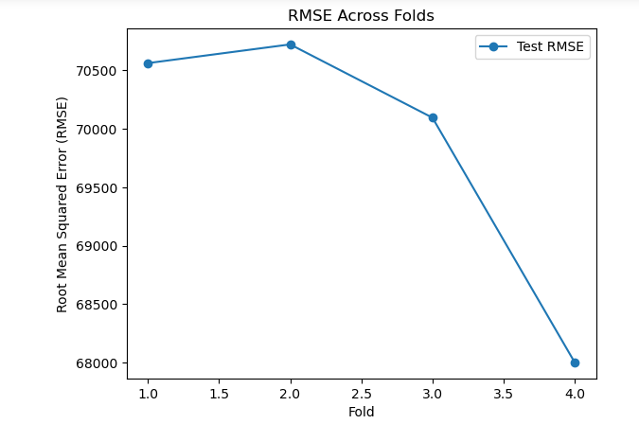 **Accuracy:**

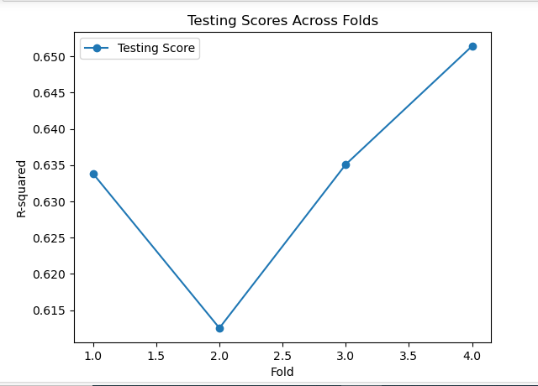

**Loss curve:**

**Model name:** KNN as regressors

|  |
| --- |
| **General Information on dataset** |

|  |  |
| --- | --- |
| Dataset name | California Housing prices |
| Total number of samples | 20640 |
| Number of samples used in training | 15480 |
| Number of samples used in validation | 15480 |
| Number of samples used in testing | 5160 |

|  |
| --- |
| **Implementation details** |

|  |  |
| --- | --- |
| Feature extracted | Non |
| Dimensionality | 10 |
| Number of k-fold | 4 |
| Ratio of training | 81% |
| Ratio of validation | 73% |
| Parameters | n_neighbors=5 , metric , p |

|  |
| --- |
| **Results details** |

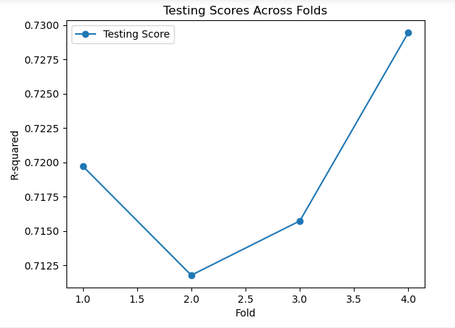 **Accuracy:**

**Loss:**

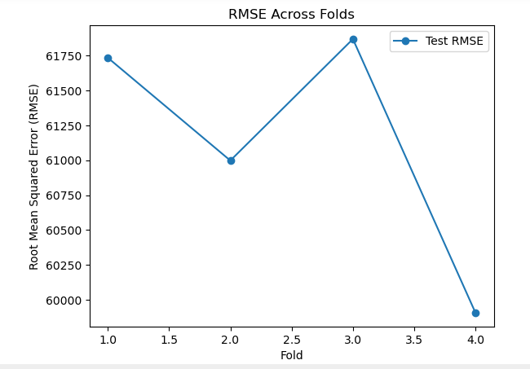

**Model name:** Logistic regression

|  |
| --- |
| **General Information on dataset** |

|  |  |
| --- | --- |
| Dataset name | Flower species recognition |
| Number of classes | 102 |
| Number of labels | 102 |
| Size of images | 520 * 500 |
| Number of samples | 8189 |
| Number of samples used in training | 6551 |
| Number of samples used in validation | 1310 |
| Number of samples used in testing | 1638 |

|  |
| --- |
| **Implementation details** |

|  |  |
| --- | --- |
| Feature extraction | HOG |
| Dimensionality | 10 |
| Ratio of training | 58% |
| Ratio of validation | 17% |
| Parameter | solver |

|  |
| --- |
| **Results details** |

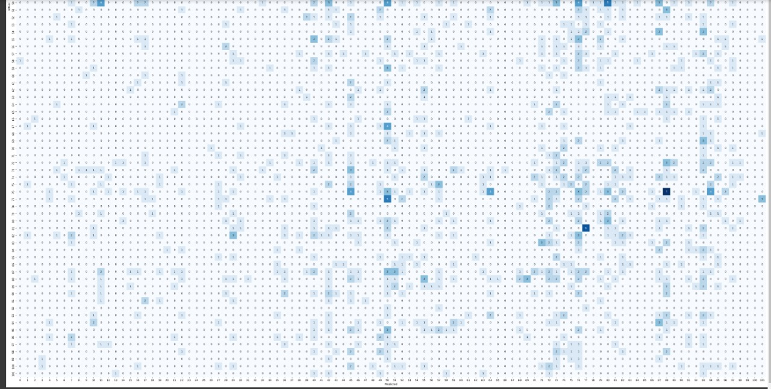 **confusion matrix:**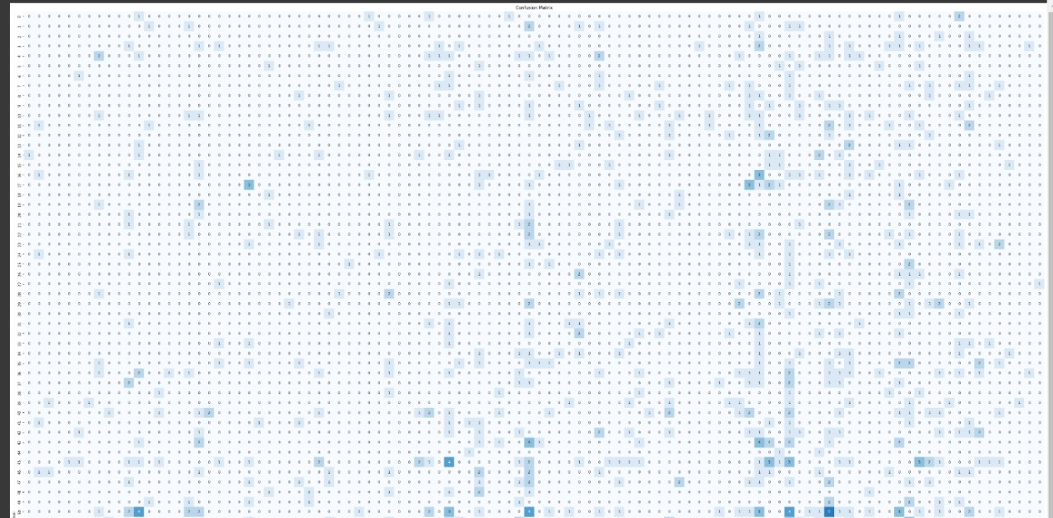

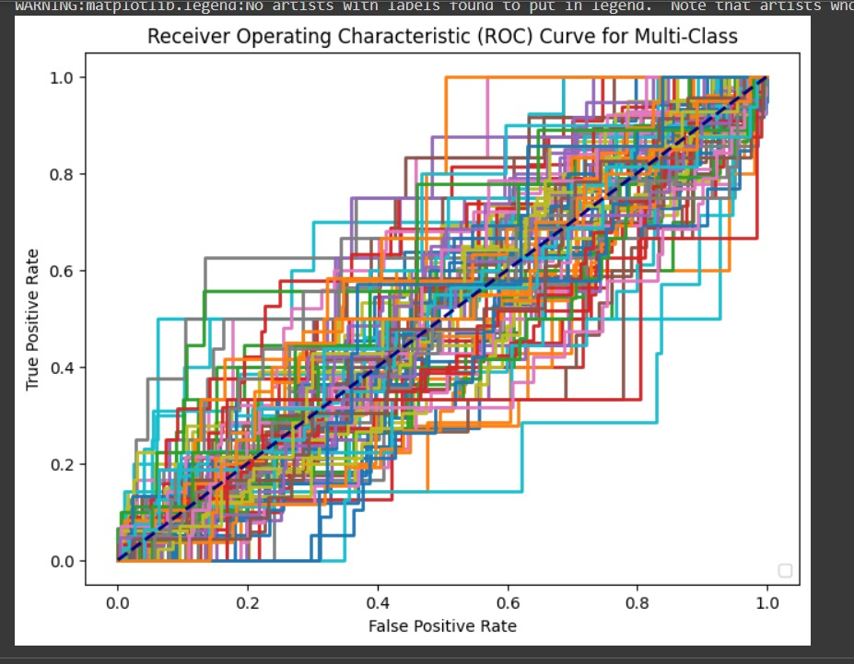 **ROC curve:**

**Model name:** K-means

|  |  |
| --- | --- |
| Dataset name | Flower species recognition |
| Number of classes | 102 |
| Number of labels | 102 |
| Size of images | 64*64 |
| Number of samples | 8189 |
| Number of samples used in training | 6551 |
| Number of samples used in validation | 1310 |
| Number of samples used in testing | 1638 |

|  |  |
| --- | --- |
| Accurcy | 20.71% |
| Parameter | **init** |

صورة تحتوي على التلون, لقطة شاشة, فن الطفل, نص

تم إنشاء الوصف تلقائياً

صورة تحتوي على نص, لقطة شاشة, رسم بياني, تخطيط

تم إنشاء الوصف تلقائياً